**Chatbot**

**(Web Application)**

Submitted by:

Name : Jay Vaghela

RollNo : CE140

ID : 17CEUON114

Name : Zeel Patel

RollNo : CE98

ID : 17CEUON063

Name : Jal Trivedi

RollNo : CE137

ID : 17CEUON058

Dharmsinh Desai University, Nadiad

Faculty of Technology

Computer Engineering Department

B. Tech. CE Semester – VI

Subject: (CE – 621) **System Design Practice**



Guided By:

**Dr. Brijesh S. Bhatt**

Professor, CE Dept.,

Dharmsinh Desai University



Faculty of Technology

Department of Computer Engineering

Dharmsinh Desai University

**CERTIFICATE**

This is to certify that the practical/term work carried out in the subject of

System Design Practice and recorded in this journal are the

bonafide work of

**VAGHELA JAY (CE-140) (17CEUON114)**

**PATEL ZEEL (CE-098) (17CEUON063)**

**TRIVEDI JAL (CE-137) (17CEUON058)**

of B.Tech semester VI in the branch of Computer Engineering

during the academic year 2019-2020.

|  |  |
| --- | --- |
| **Dr. Brijesh S. Bhatt,** | **Dr. C. K. Bhensdadia,** |
| **Professor,** | **Head and Professor,** |
| **Dept. of Computer Engg.,** | **Dept. of Computer Engg.,** |
| **Faculty of Technology** | **Faculty of Technology** |
| **Dharmsinh Desai University, Nadiad** | **Dharmsinh Desai University, Nadiad** |

|  |  |  |
| --- | --- | --- |
| **No.** | **Content** | **Page No.** |
| **1** | Abstract | **1** |
| **2** | Introduction | **2** |
| **3** | Software Requirement Specifications | **3** |
| **4** | Design | **6** |
| **5** | Implementation Details | **9** |
| **6** | Training | **11** |
| **7** | Screen Shots | **12** |
| **8** | Conclusion | **16** |
| **9** | Limitations and Future Extensions | **17** |
| **10** | Bibliography | **18** |

**Abstract**

A chatterbot or Chatbot aims to make a conversation between both human and machine. The machine has been embedded knowledge to identify the sentences and making a decision itself as response to answer a question. The response principle is matching the input sentence from user.

**Introduction**

We can safely say that we are in or at least entering the era of the chatbot. The big players, Google, Facebook, Microsoft and others, are all busy developing and improving this innovative user experience technology. Messaging applications are now more widely used than social networks, which is good news for the chatbot as they are such messaging applications!

The aim of a chatbot is to conduct conversation which allows people access to information via a lightweight messaging application. There are currently two distinct types of chatbot:

* Rule-based chatbot: These essentially work as an interactive FAQ. They’re programmed to recognize certain terms and patterns from which they can respond with pre-set answers.
* AI chatbot: These act as an artificial brain, using sophisticated cognitive and natural language processing capabilities. It not only understands requests but also context, intent, emotion and it continuously gets smarter as it learns from conversations it has with users.

**Technology Used:**

* Python3
* Flask framework 1.1.1.

**Platform Used:**

* PyCharm Community Edition 2019.3.2

**Software Requirement Specification**

**R1: Login/Signup**

Description: User can login or sign up using email or password.

**R1.1: Login**

Input: Username, Email ID, Password.

Output: Opens chat room.

Process: Validate user credentials.

**R1.2: Signup**

Input: Name, Email ID, Password, Phone no. and Username.

Output: Login page.

Process: Save User data.

**R2: Functional Requirements**

**R2.1: Chatting**

Input: Here the input would be the user query/question in English.

Output: Output will be the result/answer to the user query. If the answer to the user query is not present, then default statement “Sorry unable to process your request” would be returned.

Process: Compares the query with the queries that are present in the app database and returns the answer.

**R2.2: Learning**

Input: Here the input would be the user query/question in English whose answer is not present in the database.

Output: Statement saying “Sorry unable to process your request”. Also, the question is being recorded in the file that is maintained for such questions and answer to these questions is taken from admin.

Process: Stores the questions in a file maintained for these questions and the admin answers those questions.

**R2.3: Searching**

Input: Any user query in English.

Output: Provides search result for the query searched. If any error occurs, it displays the message “Please check your connection and try again”.

Process: Accepts user string and searches the same on net, or directly redirects the user to the website.

**R2.4: Reminders**

Input: User sets the date and time of the event.

Output: A notification to remind the user of particular event.

Process: Software accepts the date and time from user and saves that values in the application.

**Design**

1. Use Case Diagram:

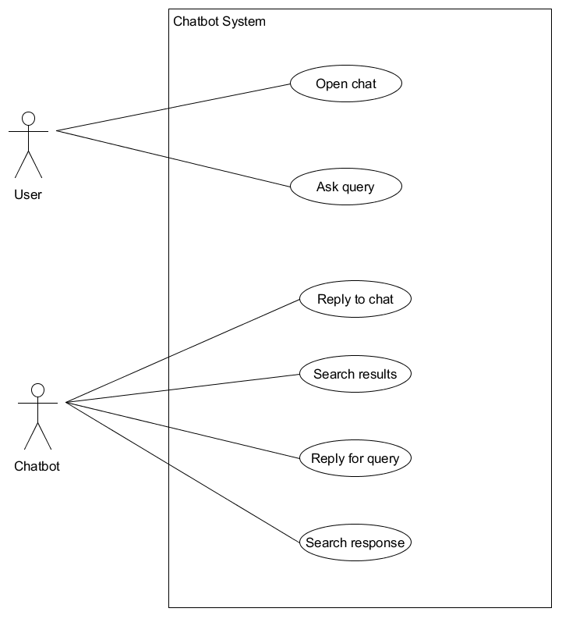

1. 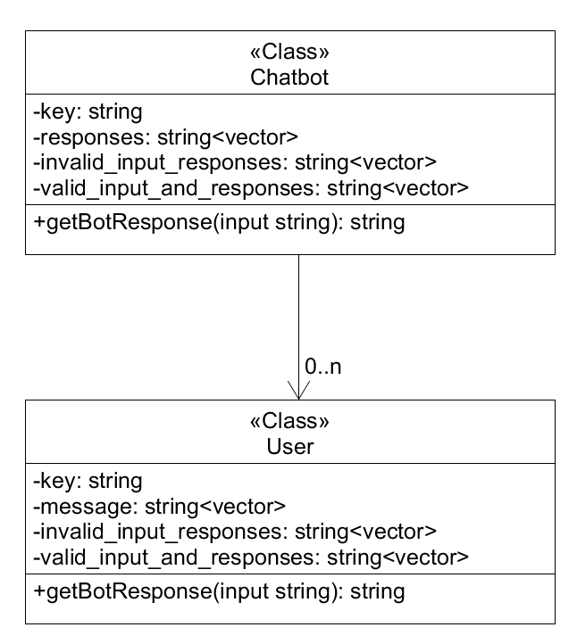Class Diagram:
2. 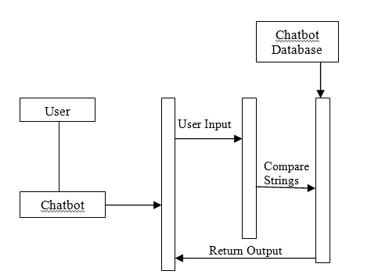Sequence Diagram:
3. Activity Diagrams:

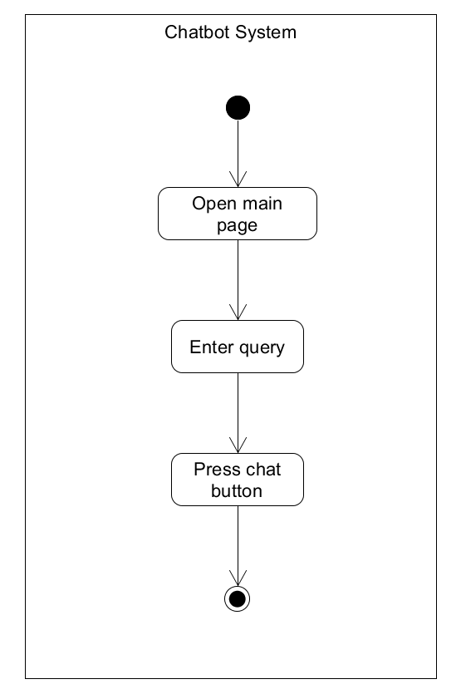

**Implementation Details**

We have made the use of Flask framework and implemented using the ChatterBot library.

ChatterBot is a Python library designed to make it easy to create software that can engage in conversation.

The dataset implemented for the chatbot is available in the chatterbot-corpus of the ChatterBot library and it consists of many languages. We can also create and use the dataset in the chatterbot-corpus.

**Modules created and brief description of each modules:**

The major module used:

**ChatterBotCorpusTrainer:**

This is module is used to train the chatbot made from the ChatterBot library. This module can train the chatbot in many languages and can be used to train our own dataset.

**Algorithm/Flowchart:**

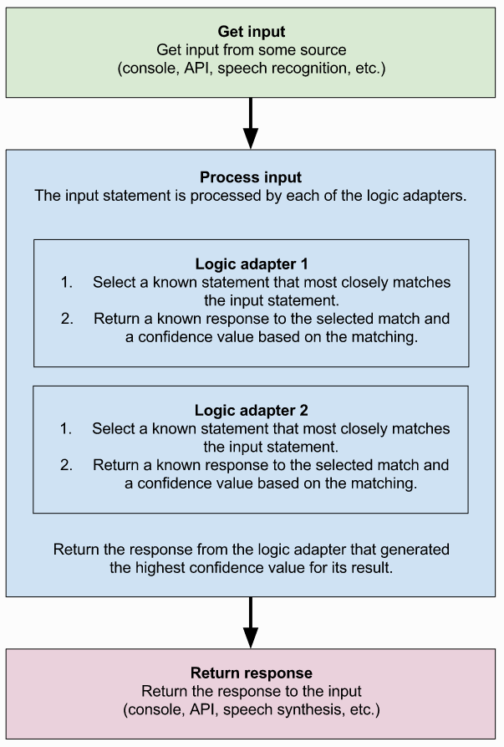

**Training**

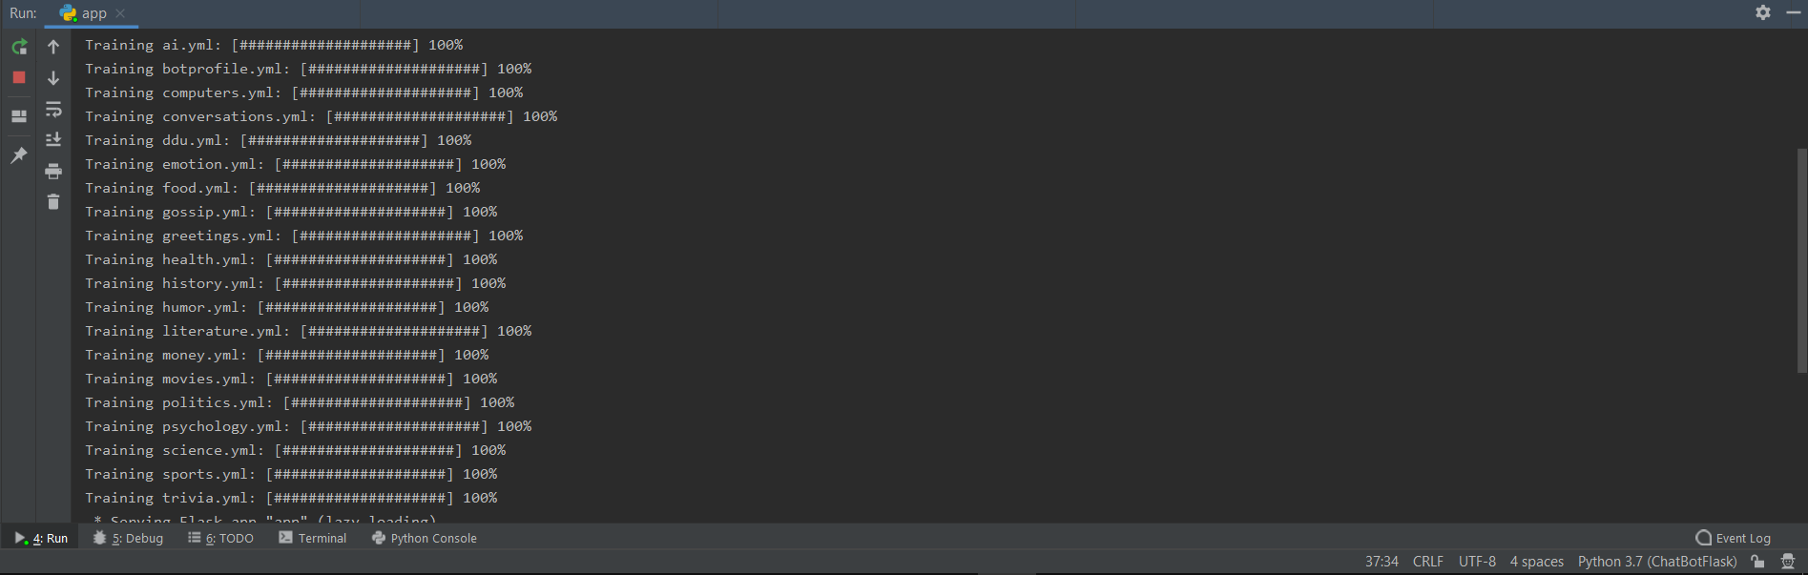

**Screen-Shots**

1. 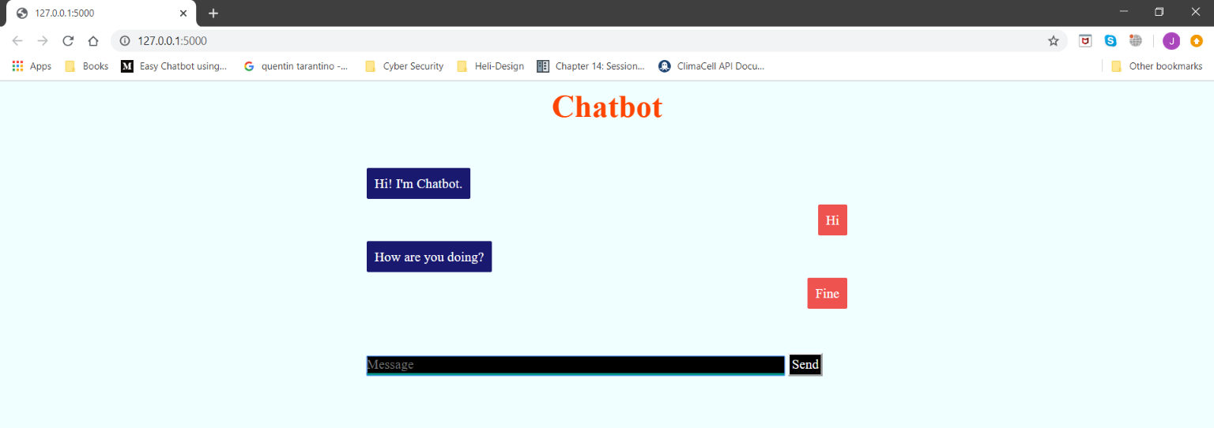**Chat**
2. **Training of the chatbot**

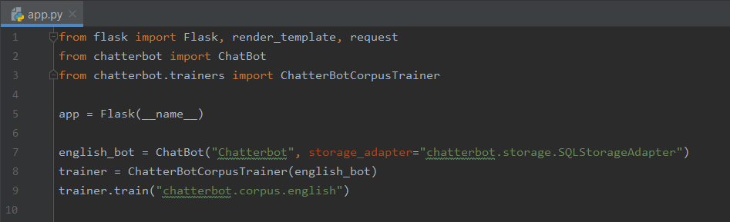

1. 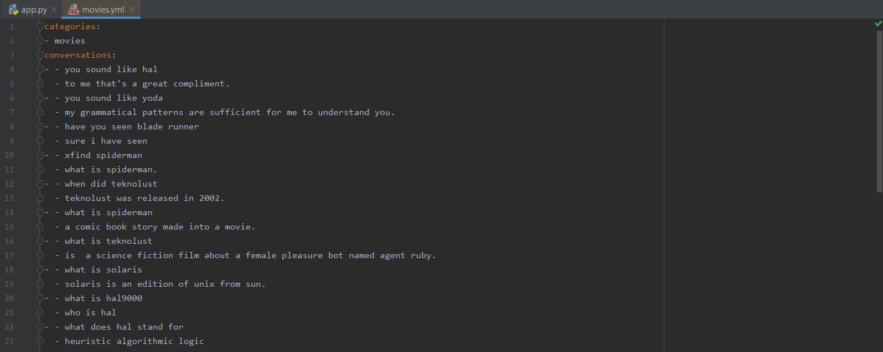**Dataset example movies.yml**
2. **Dataset example ddu.yml**

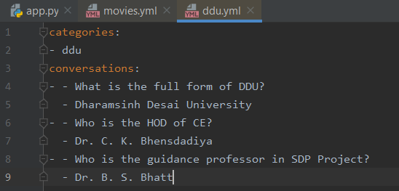

1. **Dataset example science.yml**

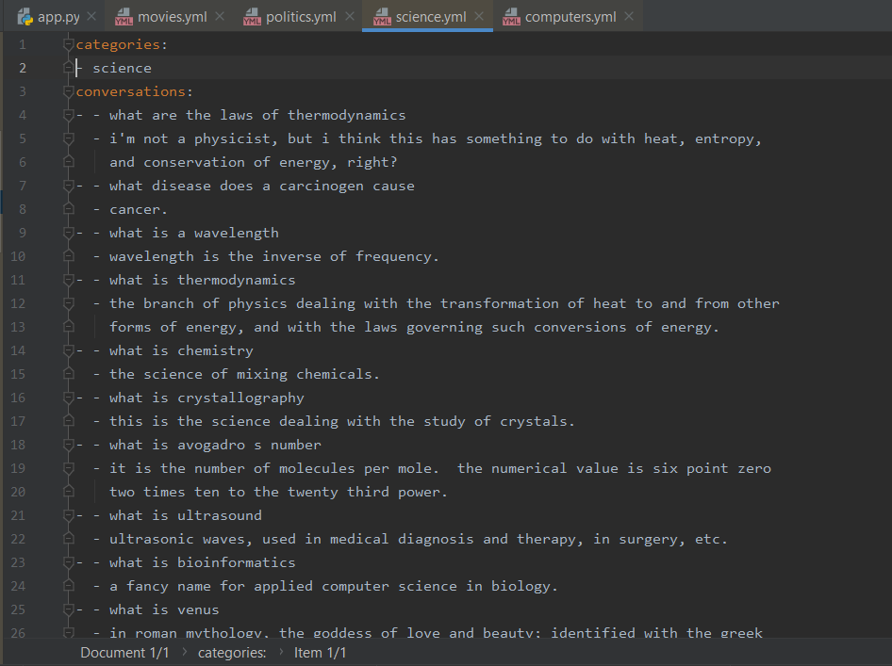

1. 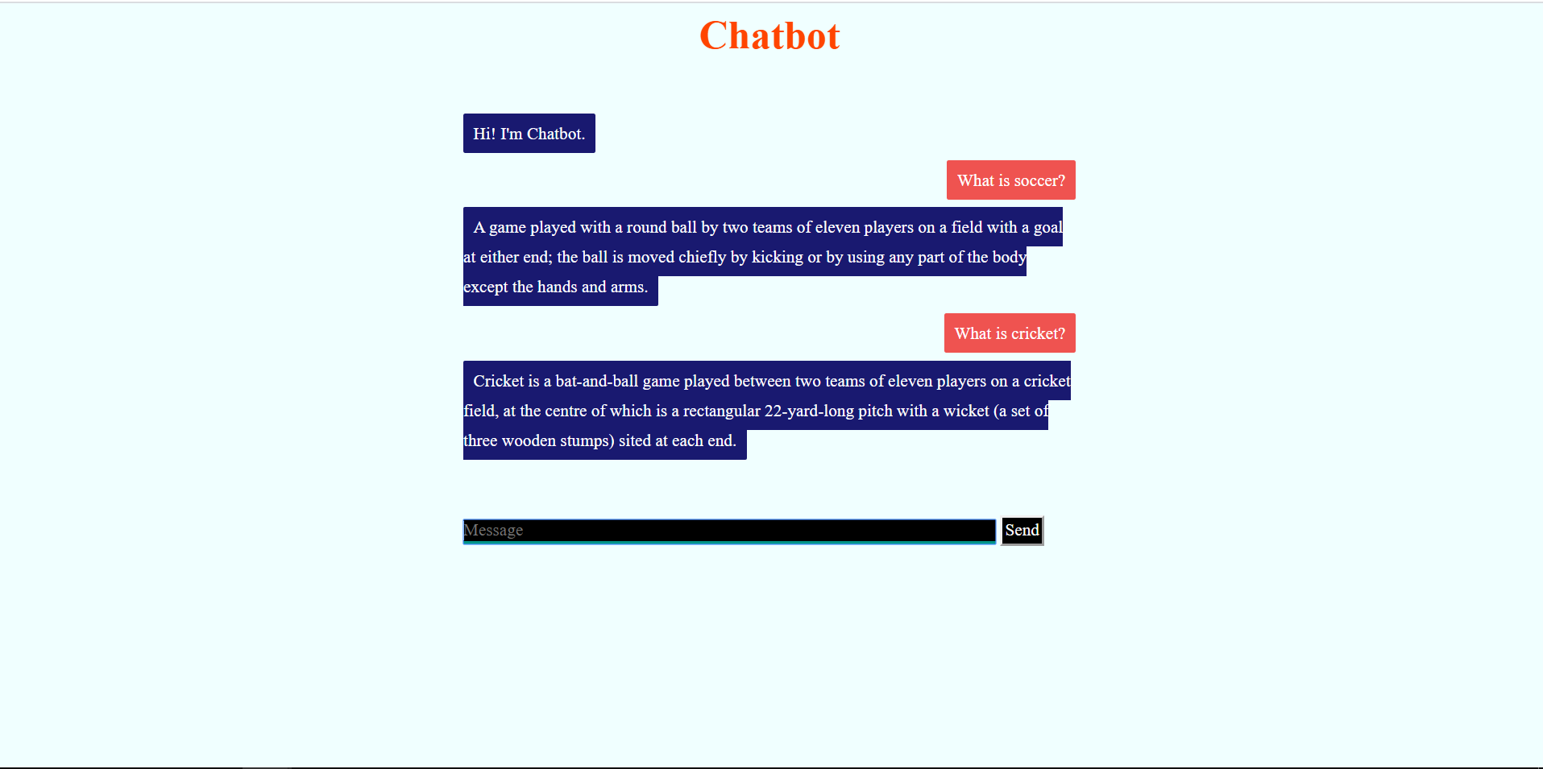**Chatbot conversation**
2. **Chatbot conversation**

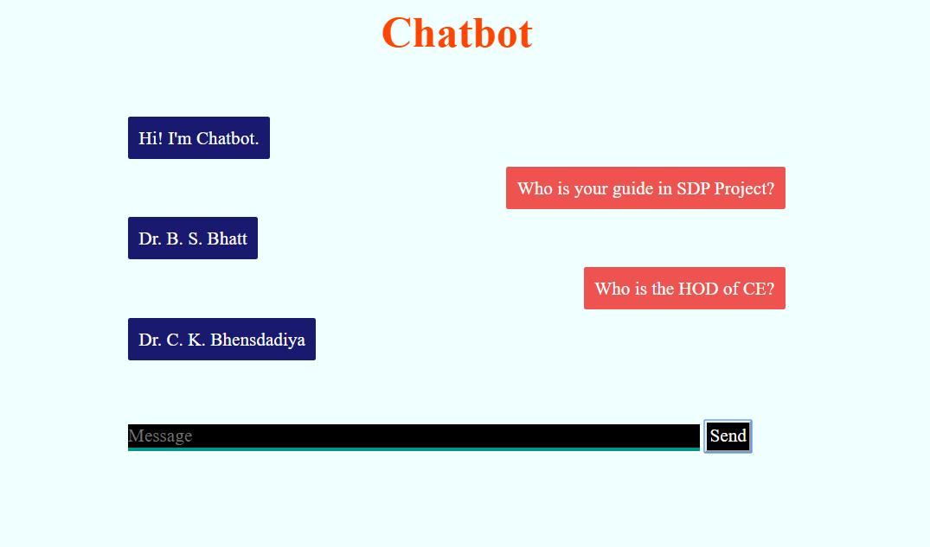

**Conclusion**

Artificial Intelligent is the fastest growing technology every were in the word. With the help of Artificial Intelligent and Knowledgeable database. We can make the transformation in the pattern matching and virtual assistance. We can develop such chat bot which will make a conversion between human and machine and will satisfy the question raised by user.

**Limitation and Future Extension**

* Defining the dataset by the user himself.
* User specific chatbot.
* Previous chats to be preserved.

**Bibliography**

<https://chatterbot.readthedocs.io/en/stable/tutorial.html>

<https://chatterbot.readthedocs.io/en/stable/>

<https://chatterbot.readthedocs.io/en/stable/corpus.html>